Dana H. Ikeda
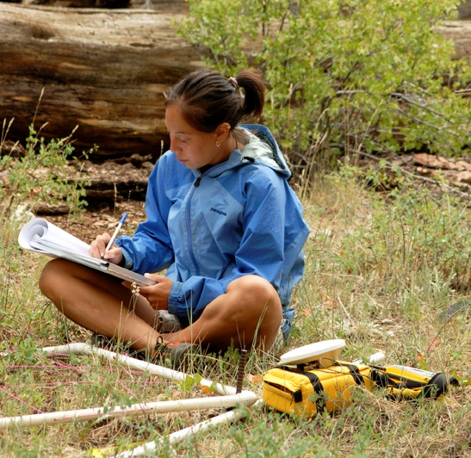
I completed my B.S. in Biology at Humboldt State University and decided to move to a drier climate for my graduate work. I finished my M.S. in Biology at NAU in the spring of 2010, looking at potential shifts in the distribution of the Utah prairie dog (a threatened species) under future climate change projections to inform current and future conservation strategies. For my PhD work I am working with Drs. Steve Shuster and Tom Whitham. I am interested in integrating our genetic based knowledge of the Cottonwood system and species distribution modeling to address a variety of questions, mainly: 1) Does accounting for local adaptation produce better climate change models, and 2) Are certain genotypes (and thus communities) predicted to do better than others under climate change? In my free time I enjoy trail-running, baking and reading non-academic literature.

